Hello dear reader. Today I am going to give you a tutorial on changing colours within Unity through using C# scripting. This is a basic tutorial mainly designed to get those who are interested in Unity and C# started and understand that not everything is as complex as it seems.

1. 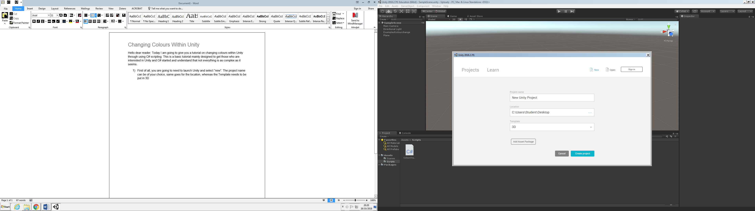First of all, you are going to need to launch Unity and select “new”. The project name can be of your choice, same goes for the location, whereas the Template needs to be put in 3D
2. 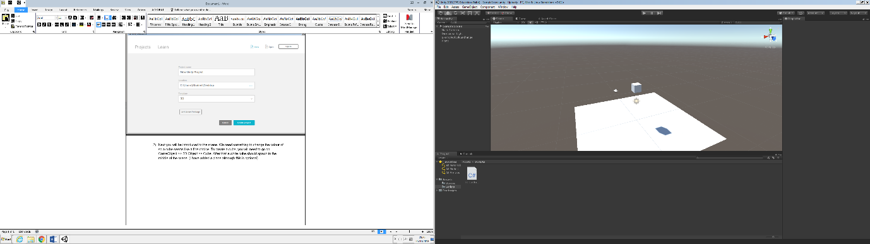Next you will be introduced to the scene. We need something to change the colour of so a cube seems like a fine choice. To create a cube, you will need to go on GameObject >> 3D Object >> Cube. After that a white cube should spawn in the middle of the scene. (I have added a plane although this is optional)
3. 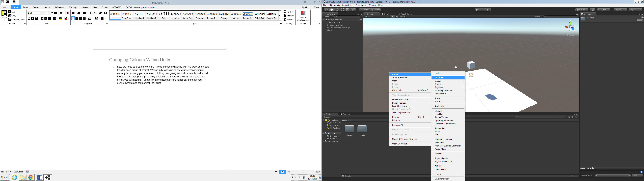Next we need to create the script, I like to be somewhat tidy with my work and create files for each group of project. When Unity loads up below your screen it should already be showing you your assets folder, I am going to create a scripts folder and create a C# script (A script to Unity is known as a newbehaviour). To create a C# script, you will need to: Right click in the assets/scripts folder bar beneath your scene, Create and then select C# Script.(it is important that you name all of your scripts differently and don’t change their name within Assembly-CSharp)
4. 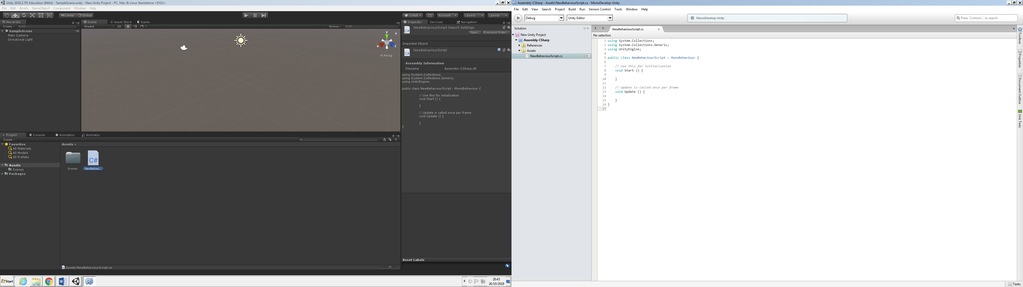So we now have a C# script, but we need to change it so double click on it, then an application called Assembly-CSharp.
5. First off you have to type Renderer myRenderer;
6. Then underneath void start put (it is important to put; at the end as if you don’t errors will appear.)

 myRenderer = GetComponent<Renderer> ();

1. Then you will want to type

        if (Input.GetKeyDown (KeyCode.R)) {  
            myRenderer.material.color = Color.red;  
        }  
        if(Input.GetKeyDown (KeyCode.B)) {  
            myRenderer.material.color = Color.blue;   
        }  
    }   
}